**Disease Detecting in NIH Chest X-ray Images**

**Author Names Go Here Using the Author Name Style (Required)**

Affiliations and Addresses Go Here Using the Affiliation and Address Style (Required)  
publications21@aaai.org (email is text roman font using Affiliation and Address Style (Required)

[*At least 3 carriage returns must separate the author affiliation block from the beginning of the two-column text block*]

**Abstract**

Chest X-ray exams are one of the most frequent and cost-effective medical imaging examinations available.

However, clinical diagnosis of a chest X-ray can be challenging and sometimes more difficult than diagnosis via chest CT imaging. By using machine learning and deep learning techniques, we aim to ease the detection and classification of various lung disease. This paper proposes and compares the performance between ML model with Manual Feature extraction, ML Models with CNN features and deep learning Neural network models. This paper concludes with the best performing model from through experimentation.

**Introduction**

Large-scale multimedia data has accelerated the development of tasks in computer vision, such as image retrieval and classification, video analysis. In radiological studies, Chest X-ray (CXR) is one of commonly used screening techniques in thorax disease diagnosis, such as Pneumonia, nodules, cardiomegaly, effusion etc. Thousands of CXR images are captured in hospitals, making the computer-aided diagnosis (CAD) very important but challenging. Therefore, automatic analysis of CXR images would effectively assist clinical diagnosis and pathology finding. However, chest X-ray image analysis is a challenging task which suffers from the intrinsically complex relations of different pathologies. In this paper, we conduct experiments with deep learning techniques and multiclass and Multi label machine learning techniques.

The dataset used in this project is from the National Institute of Health (NIH). This NIH Chest X-ray Dataset consists of 112,120 X-ray images with disease labels from 30,805 unique patients. To create these labels, the authors used Natural Language Processing to text-mine disease classifications from the associated radiological reports. The labels are expected to be >90% accurate and suitable for weakly-supervised learning.

There are 15 classes (14 diseases, and one for "No findings"). Images can be classified as "No findings" or one or more disease classes.

Atelectasis, Consolidation, Infiltration, Pneumothorax, Edema, Emphysema, Fibrosis, Effusion, Pneumonia, Pleural thickening, Cardiomegaly, Nodule Mass, Hernia.

Commonly, CXR images are labeled with one or more pathologies, which makes the CXR image classification a multi-label problem. In the NIH Chest X-ray dataset, each image is annotated with multiple lung-related pathologies. In this paper we propose and experiment with multi-label and multiclass Machine Learning models.

Deep learning has made noticeable progress in the field of medical image analysis, such as classification, segmentation or detection, and image registration. In this paper we propose and have designed a purpose built Convolutional Neural Network and experimented with multiple Pretrained Deep learning Models such as Resnet 161, Resnet 152, Resnet121, VGG16.

Summarized Contributions

* CNN Pretrained models – experimenting with hyper parameter configuration of pretrained ML models
* Traditional ML models with CNN features – extracting features generated by our CNN models and using them to train traditional ML models.
* Traditional ml models with Manual features. – using Manual feature extraction methods like GLCM, LBP and discrete Wavelet transforms to extract features from CXR images and training traditional ML models with these features.

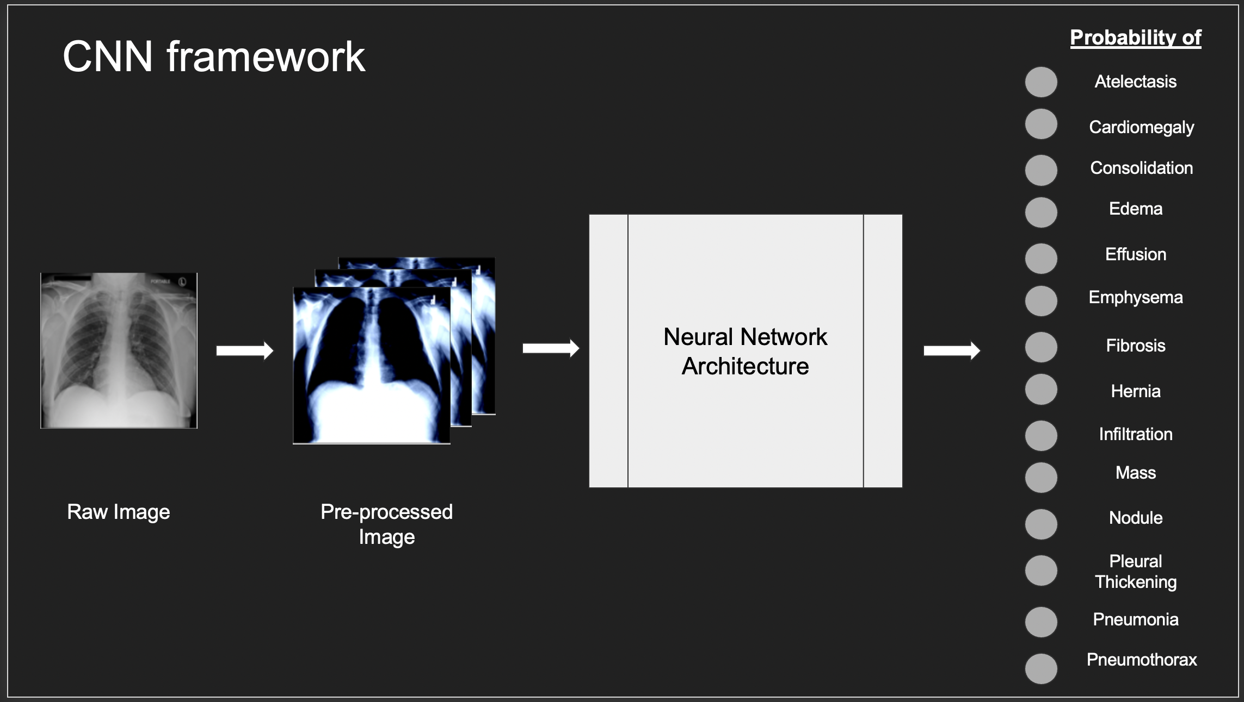

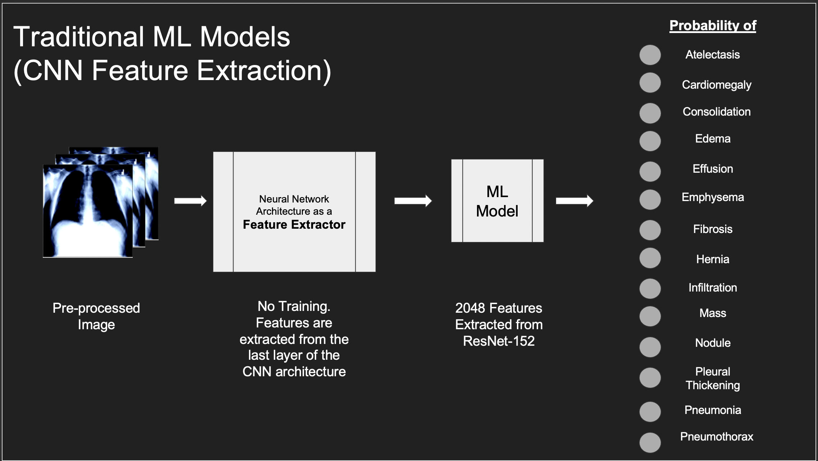

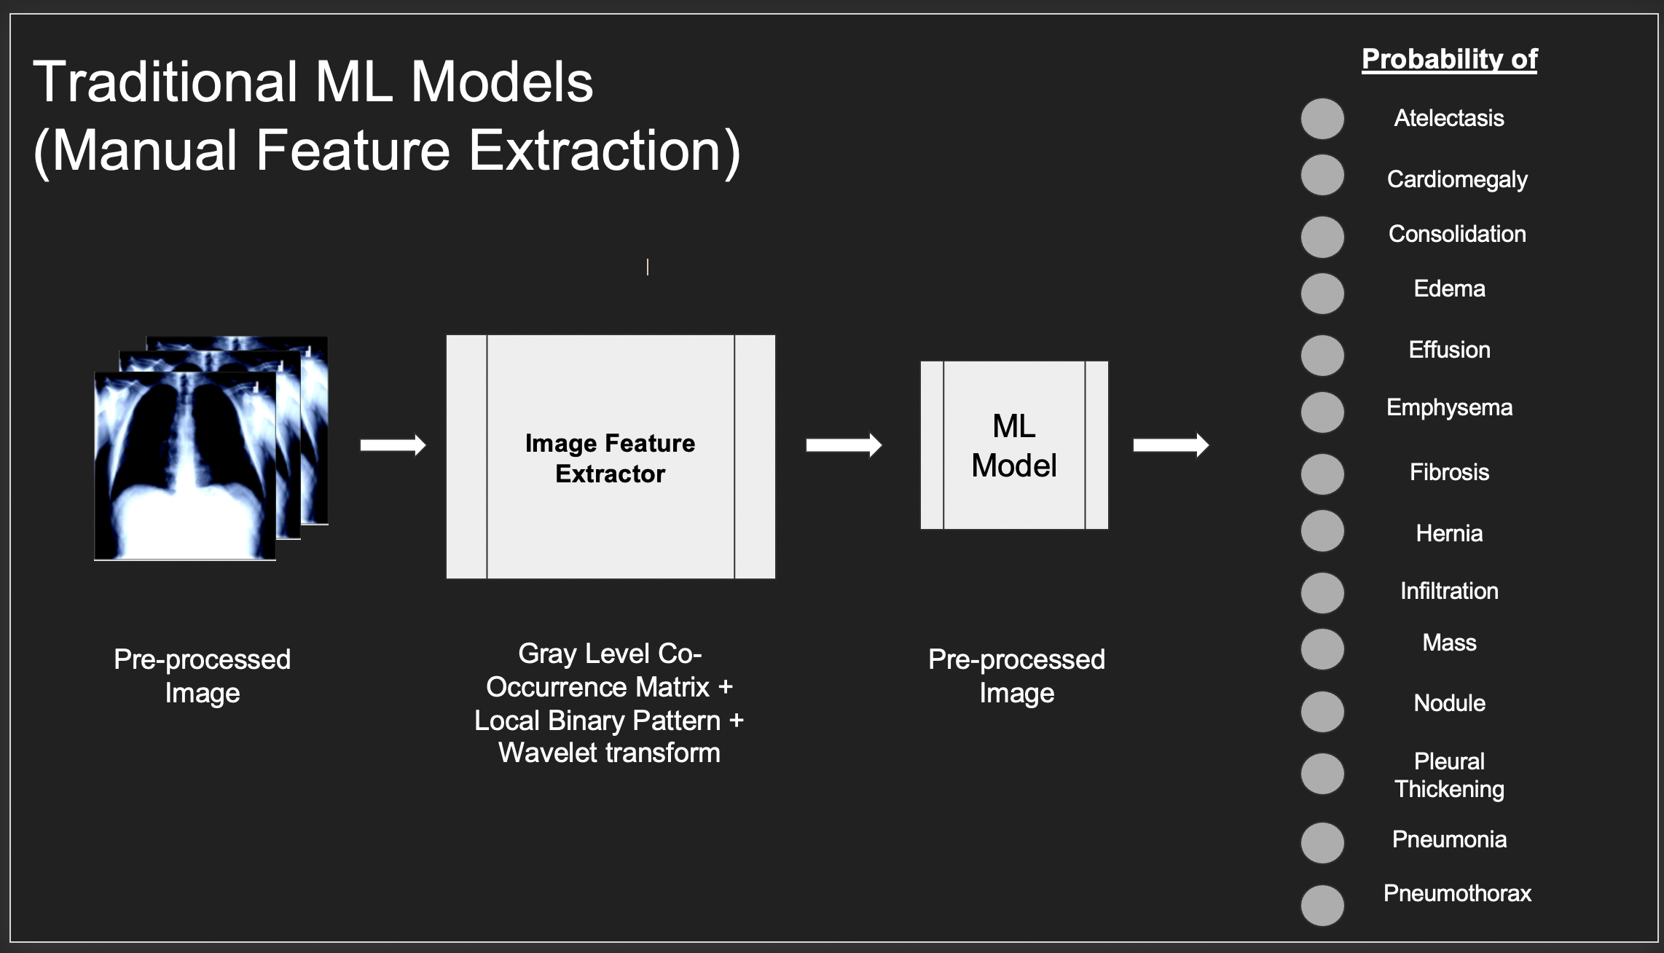

**Background**

**Manual Feature Extraction**

**Local Binary Pattern**

LBP is an effective texture pattern descriptor introduced by Ojala et al. to describe the local texture patterns of an image. It is a very effective and popular image processing method. LBP is a visual descriptor. The LBP works on the principle of sliding windows and radius. Divide the input image into its pixels, in a block size of 3×3, in which the center pixel is used as a threshold for the [neighboring pixel](https://www.sciencedirect.com/topics/engineering/neighboring-pixel), and the LBP code of a center pixel is generated by encoding the computed threshold value into a decimal value.

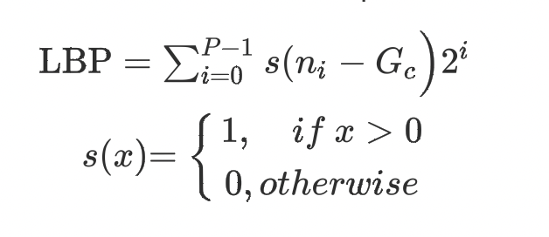

**Grey Level Co-Occurrence Matrix**

The grey level co-occurrence matrix is a method used to extract texture features from an input image. The texture is computed as an element of combination of intensities at specific regions in the image. According to the intensity values generated throughout the image, the image can be statistically ordered as levels. Based on the data the exact level required for statistically acceptable detail is decided.

The GLCM computed a matrix of the image to pinpoint Regions of interest that might hold important features.

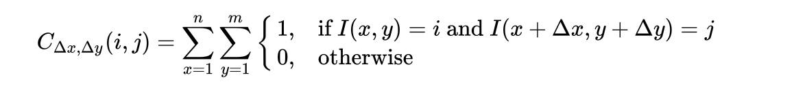

**Discrete Wavelet Transforms**

Wavelet transform is widely used in image classification as an image processing technique.

Discrete wavelet transform for image processing transforms the input image into Wavelet coefficients. Feature extraction is possible when these coefficients are calculated under a specific form of wavelet.

wavelet transforms were developed in place of Fourier transforms to overcome problems related to its frequency and time resolution properties. The basic idea of DWT is to provide the time-frequency representation. The 2D-DWT represents an image in terms of a set of shifted and dilated wavelet functions

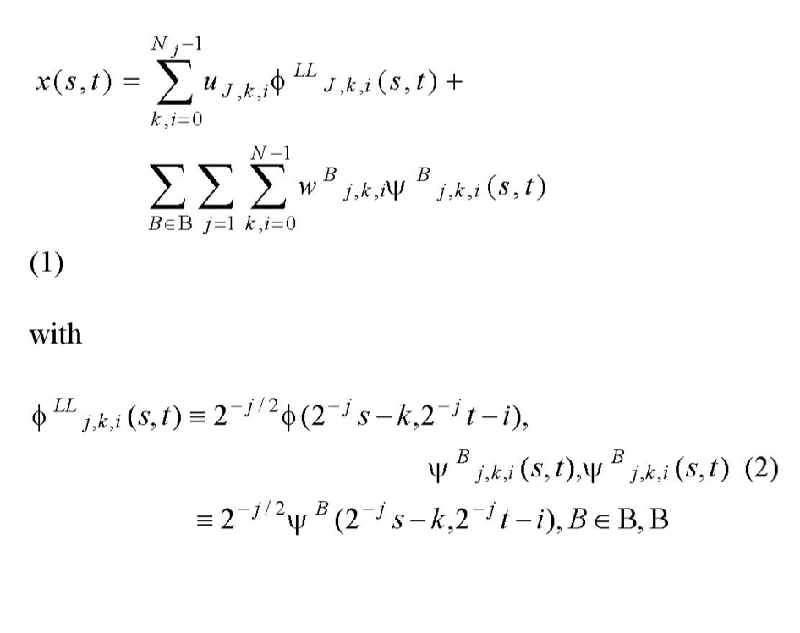

{LH, UL, HH}, and Nj =N/2. In this paper LH, UL and UVI are called wavelet or DWT sub-bands.

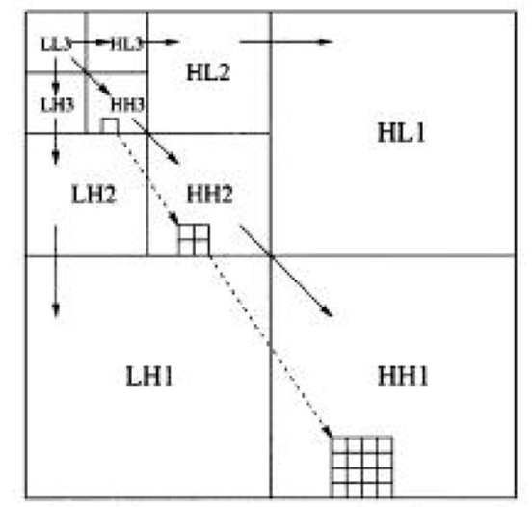

**Machine Learning Models**

**Multinomial Logistic regression**

Multinomial logistic regression is a classification method designed for multiclass problems. This permits for the model to have more than a binary outcome, which is necessary if you want to predict the probabilities in a multi class multi label problem. In this case to predict the probability of 14 distinct lung disease labels. The data can be categorically distributed given a set of real independent values.

Multinomial logistic regression is a solution to classification problems that use a linear set of observed features and problem specific conditions to calculate the probability of each target label . Prediction function:



**Bernoulli NB**

Bernoulli Naive Bayes is a type of Naive Bayes. BernoulliNB implements the naive Bayes training and classification algorithms for data that is distributed according to multivariate Bernoulli distributions.

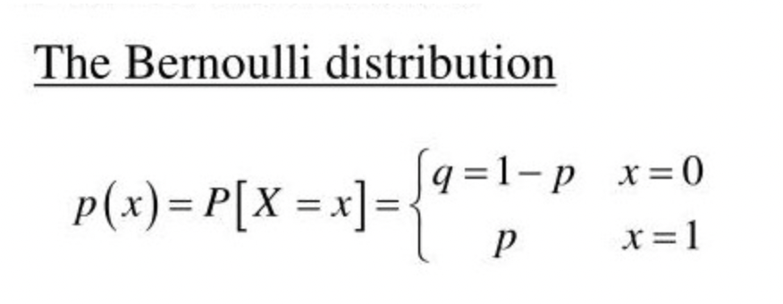

The main feature of Bernoulli Naive Bayes is that it accepts features only as binary values vectors. So, when the feature values are binary, we know that we must use Bernoulli Naive Bayes classifier.

The decision rule for Bernoulli Naïve Bayes:

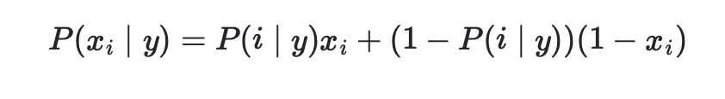

**Gaussian NB**

[Gaussian Naive Bayes](https://iq.opengenus.org/gaussian-naive-bayes/) is a type of [Naive Bayes](https://iq.opengenus.org/text-classification-naive-bayes/) that follows Gaussian normal distribution and supports continuous data.

When working with continuous data, an assumption often taken is that the continuous values associated with each class are distributed according to a Gaussian distribution. The likelihood of the features is assumed to be-(sd – standard deviation)

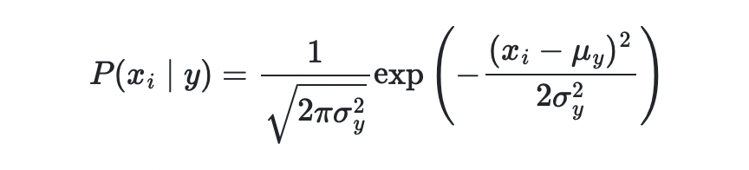

**Decision Trees Classifier**

Decision tree classifier is a supervised machine learning algorithm that uses a set of rules to make decisions.

It uses a decision tree to go from observations about an item that is represented in the branches to conclusions about the target value that is represented in the leaf nodes.

The idea in decision trees is that you use the features from the data to make binary conditions to split the input continuously, until you reach isolation for every target class.

Tree models where the target variable can take a discrete set of values are called classification [trees](https://en.wikipedia.org/wiki/Decision_tree); Decision trees where the target variable can take continuous values (typically real numbers) are called regression [trees](https://en.wikipedia.org/wiki/Decision_tree). Decision trees are among the most popular machine learning algorithms given their intelligibility and simplicity.

The decision trees require loss functions to evaluate the split based on resulting nodes. the two loss functions in trees are ‘Gini’ and ‘Entropy’

Gini

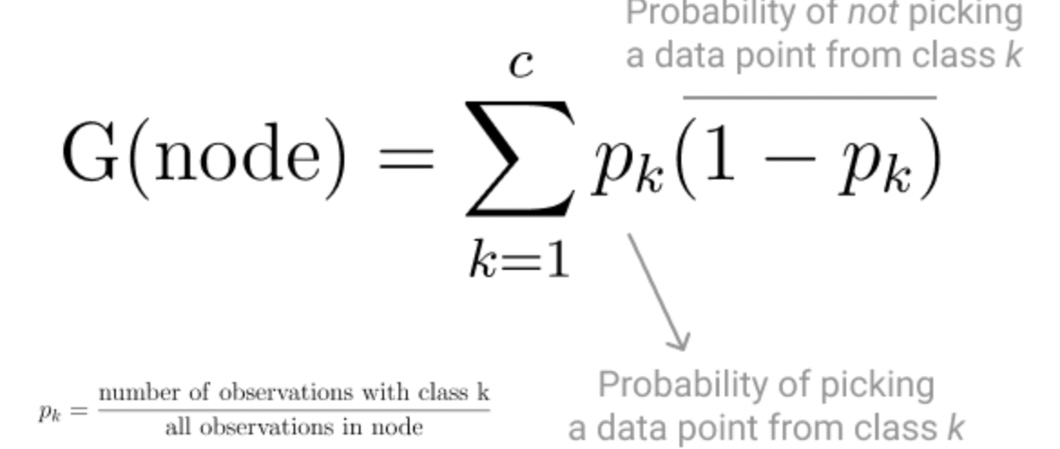

Entropy

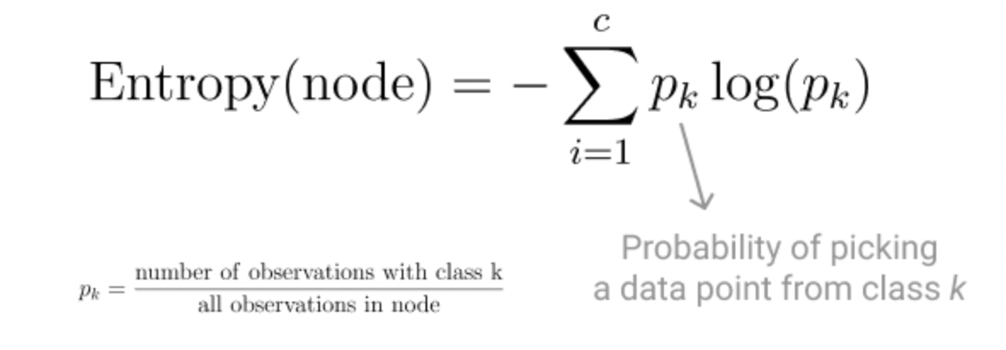

**Extra Tree Classifier**

Extremely RandomizedTrees Classifier (Extra Trees Classifier) is a type of ensemble learning technique which aggregates the results of multiple de-correlated decision trees collected in a “forest” to output its classification result. It is very similar to a Random Forest Classifier and the only difference is the manner of construction of the decision trees in the forest.

The Extra-Tree methods main objective is to randomizing tree building in the context of numerical input features, where the choice of the optimal cut-point is responsible for a large proportion of the variance of the induced tree

The extra tree selects the split of every decision tree typically by the GINI criteria. And the random sample of features leads to the creation of multiple de-correlated decision trees.

**Deep Learning Models**

**Convolutional Neural Networks**

A Convolutional Neural Network, also known as CNN, is a type of Neural Network that is well suited for image classification. A digital image consists of pixels in a grid fashion, a specific image is formed by a combination of RGB colour and brightness specified in each pixel.

Similar to how a human brain derives knowledge from vision, through a network of neurons in the brain. Each neuron in a CNN processes data similarly, by detecting patterns from its field of view. The layers in CNN are set up to dissect features at each level in the network, and more complex patterns (faces, objects, etc.) further along the network it goes.

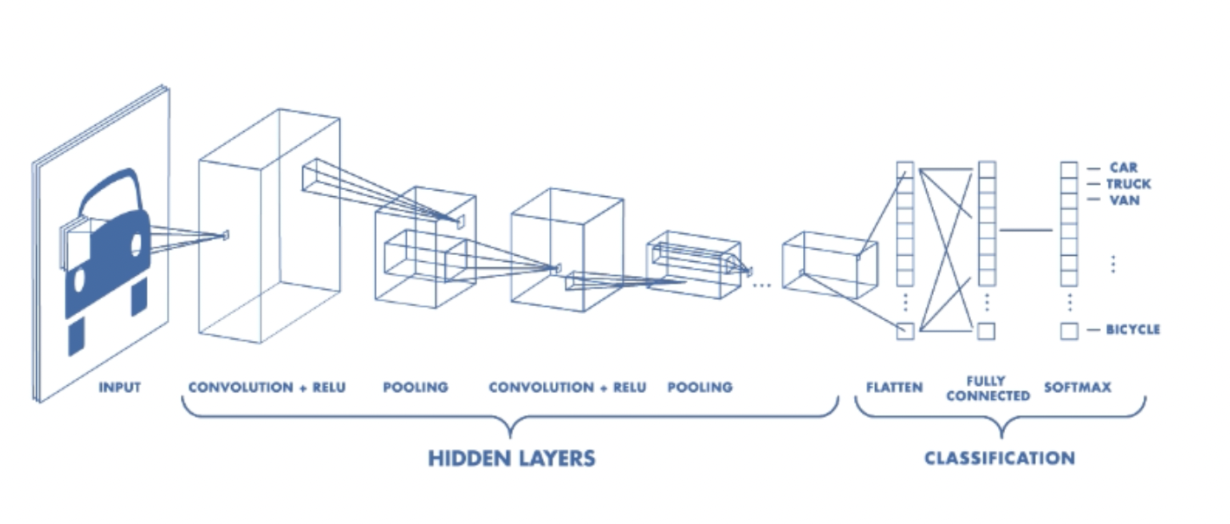

**Convolutional Layer**

The Convolutional layer is the concept that distinguishes CNN from other Neural networks.

This layer performs a dot product between two matrices, where one matrix is the set of learnable parameters(kernel), and the other matrix is the specific portion of an image. The kernel is of smaller dimension than the image but captures and compresses more detail. The kernel for an RGB model has the same dimensional depth as the input image but the window is always smaller.

.

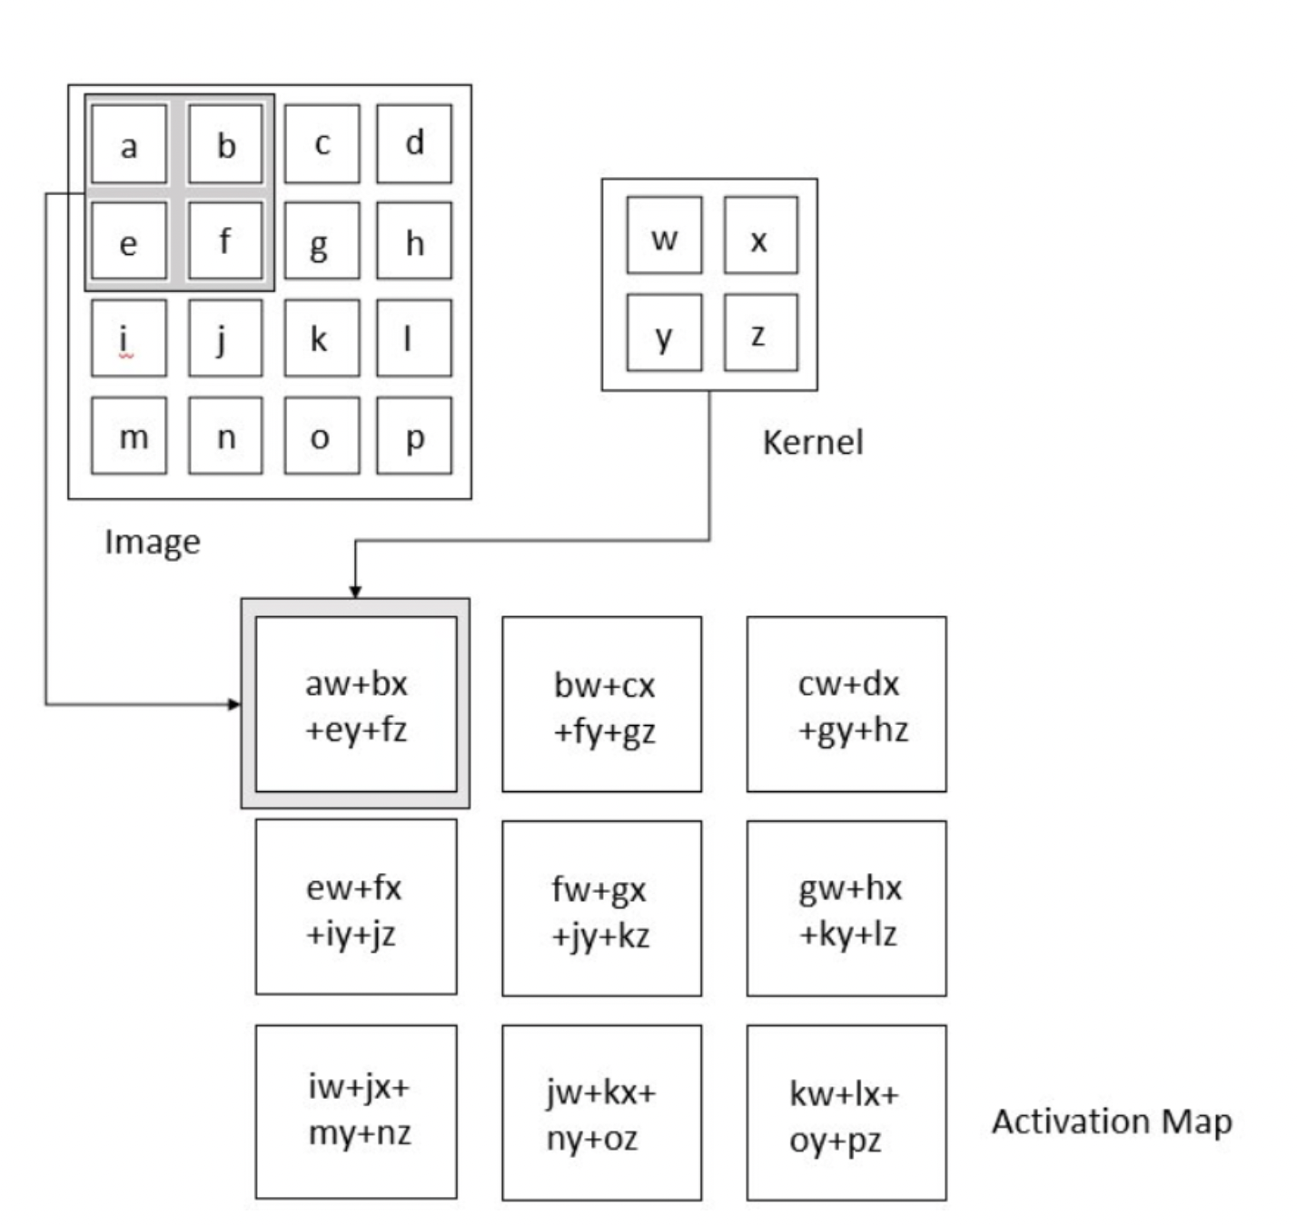

**Related Work**

**This Is a Subsubsection Heading. Use of This Style Sheet Is Required for all subsubsections.**

**Project Description**

In this section, we introduce the details of the proposed system for the multi-class and multi-label chest X-ray image classification. We will first describe Data preprocessing used . Then, the feature extraction module and then the ML and Deep learning models.

**Data preprocessing**

**Sample of Raw images**

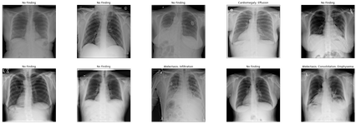

**Images after preprocessing**

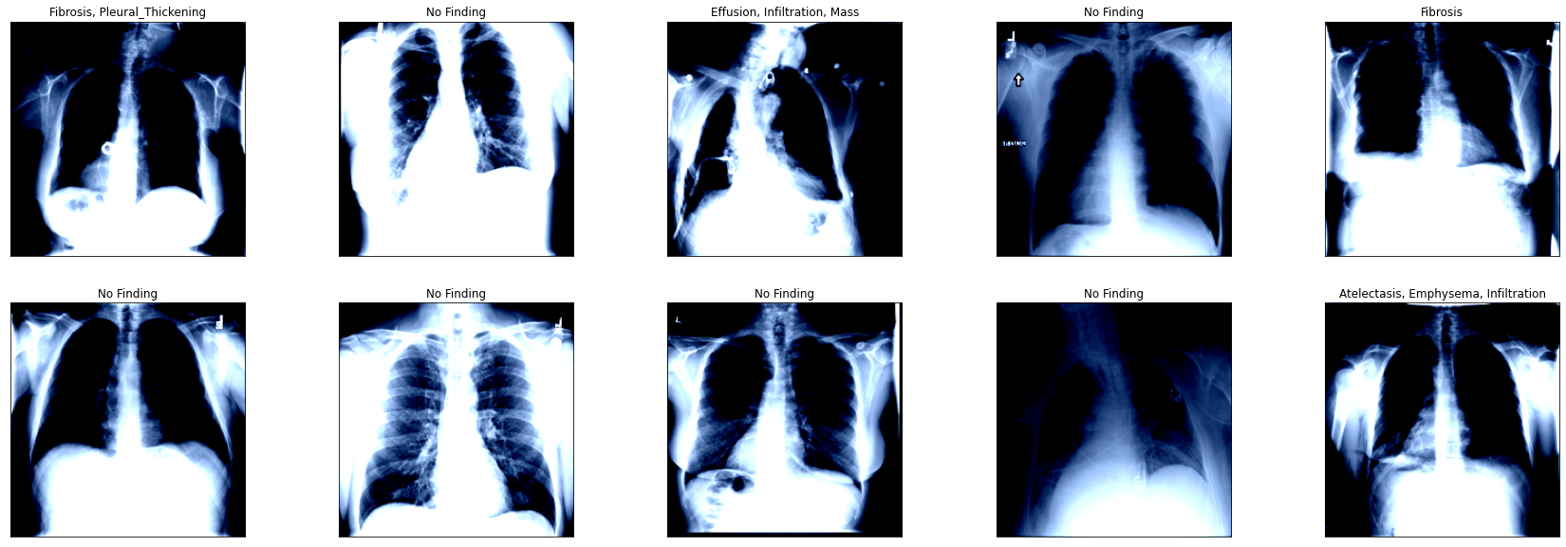

The Raw image dimensions are 1024x1024 which is too large to be processed, so they are first resized to 224x224, this size retains most of the detail needed for Image classification and feature extraction and at the same time being small enough to work with above models. The images are then converted from grayscale to rgb , because The 3 layer RGB image in X Ray results in much more detailed features than single layer grayscale images. The images are normalized for even data distribution.

Random Horizontal Flip is a type of image data augmentation which horizontally flips a given image with a given probability. The intuition behind **flipping** an image is that an object should be equally recognizable as its mirror image. Note that **horizontal flipping** ...

**Preprocessing metadata**

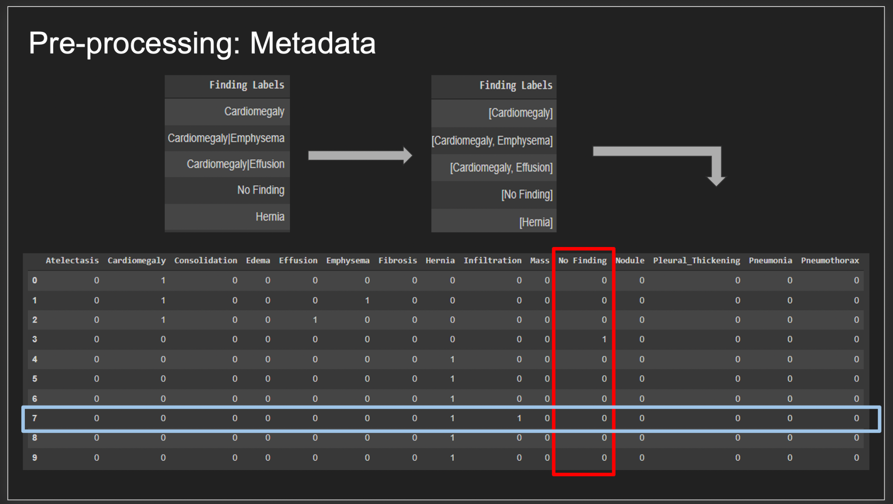

The NIH CXray dataset provides categorical data of the image labels, which must be preprocessed into an acceptable format to work with ML and Deep leaning models. The labels are first converted into one hot encoded vector containing all the 15 classes present in metadata. Now ‘1’ represents the presence of label and ‘0’ represents the absence of a label. This is suitable for a general multi-label ,multi-class classification. But we found that due to the uneven distribution in labeled images where No findings dominated the entire dataset (approx. 60,000+ images), all the models overfit to one specific label i.e No Findings and the accuracy for all other labels were insignificant.

Upon research it was found that dummy encoding the metadata and eliminating the ‘No Findings label’ produced significant improvements in all the models. The dataset still contained the images mapped as ‘No Findings’ but by removing the label alone the CNN model is able to focus on actual disease labels and ignore ‘No Findings’. The vectors now belong to only the 14 disease labels and ‘No findings’ is represented in data when all other labels are set to ‘0’.

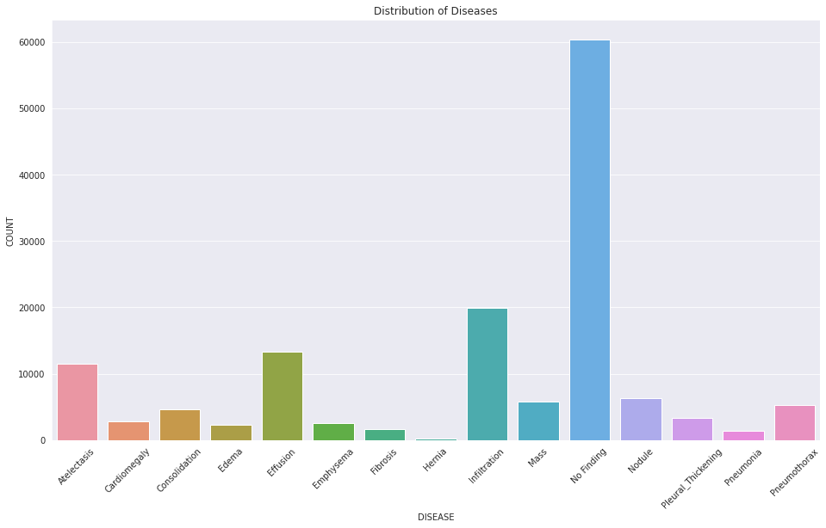

**CNN models**

**Experiments**

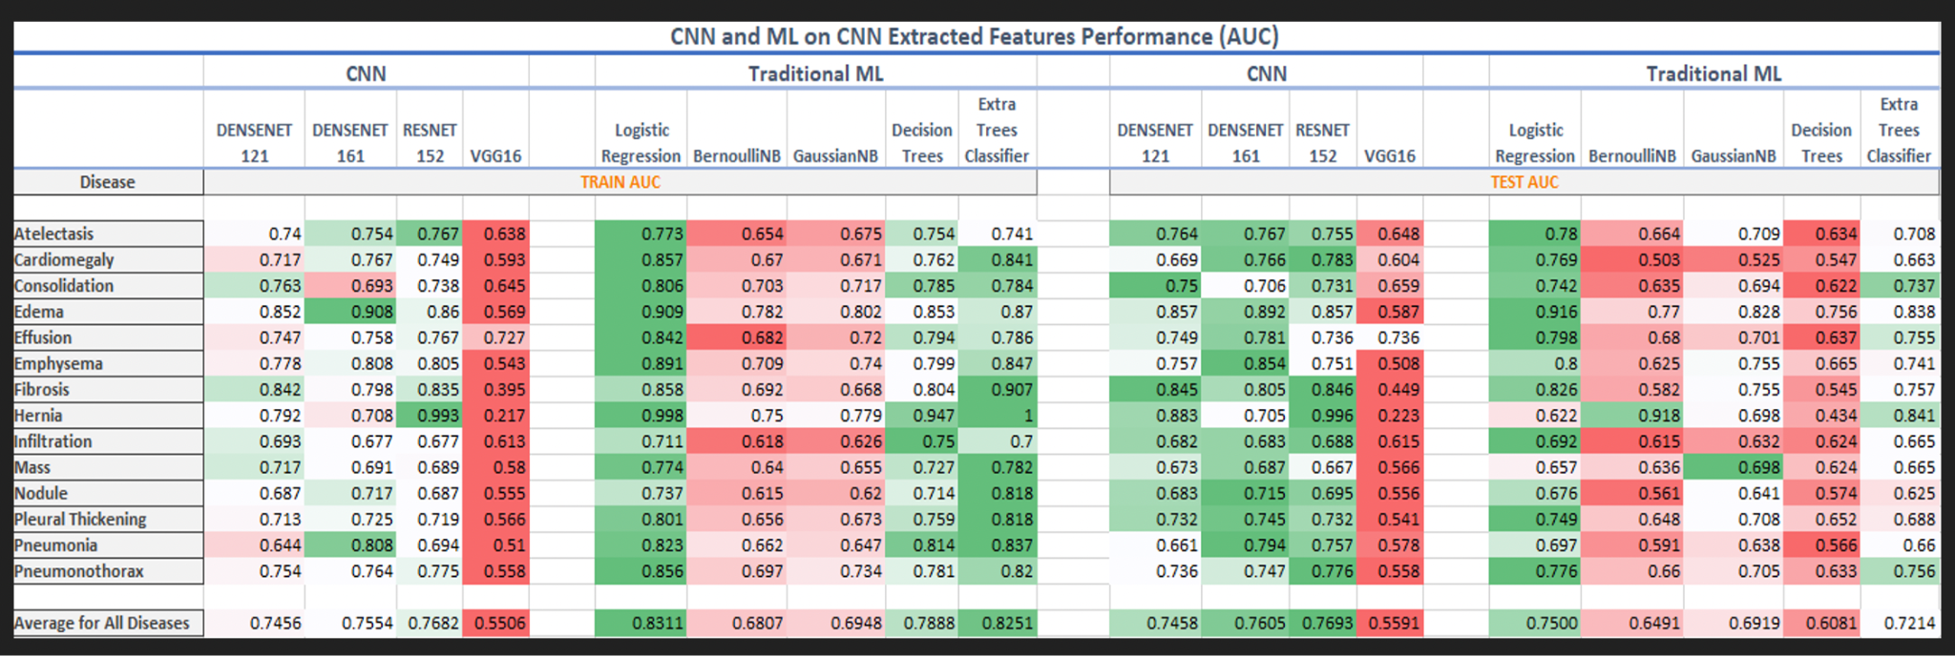

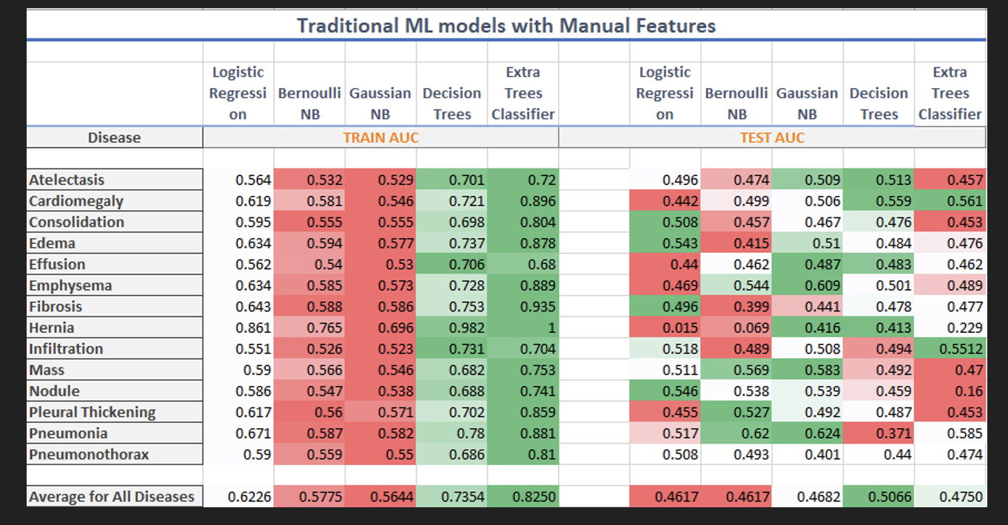

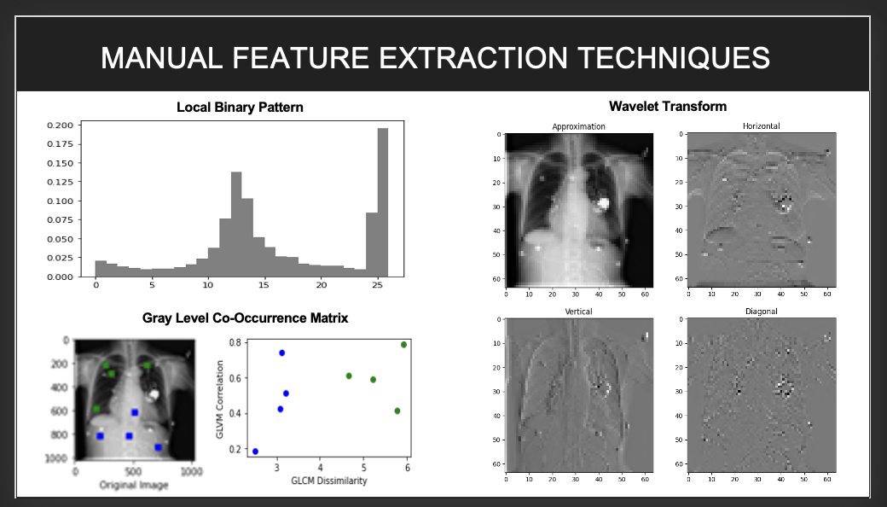

**Conclusion**

All AAAI papers must use author year citations in the text (Engelmore and Morgan 1986). Numbered references may not be used. The references must be formatted using the exact references style shown the Author

**Citation Style and Reference Style**

All AAAI papers must use author year citations in the text (Engelmore and Morgan 1986). Numbered references may not be used. The references must be formatted using the exact references style shown the Author Formatting Instructions for Authors Using Word. Citations must be placed in alphabetical order. Lines must be justified. References may not be numbered. No indent is allowed. The style sheet will automatically add the proper amount of space between entries; no additional space should be added.

**References**

Clancey, W. J. 1984. Classification Problem Solving. In *Proceedings of the Fourth National Conference on Artificial Intelligence,* 49-54. Menlo Park, Calif.: AAAI Press.